Short Description:
FloBio, LLC was established September 2017 as a spin-out from the University of Pennsylvania. FloBio is focused on the innovation of microfluidics (MF) and blood testing technologies. Although MF devices have been widely used in research labs, they have rarely been used point of care (POC) due to obstacles in manufacturing scale up and ease of operation.

The vision of FloBio is to advance POC blood diagnostics by developing an easy to use, scalable approach that requires small amounts of blood, providing relevant, complete and accurate information when needed. Providing granular and specific information (vs the competition) will allow clinicians to rapidly and confidently engage in targeted goal directed interventions, optimal resource utilization and improved patient outcomes.
It is anticipated that FloBio will have utility across a broad range of clinical scenarios where understanding a patient’s bleeding and clotting risk is paramount.
Key clinical situations of relevance include: trauma injury, major surgeries, organ transplants, cardiac surgery & procedures, as well pharmacological management of therapeutics, including anti-platelet and anticoagulant therapeutics. Specific populations such as Neonates/Children also can benefit from POC blood testing using small amounts of blood.
What is the problem that your company addresses and how does your product solve this problem?
In order to effectively manage patient’s bleeding and thrombotic risks, clinicians require the most complete and relevant information when they need it, to diagnose and/or monitor underlying hemostasis defects. Early identification and timely fixing of these defects is important to reduce the risk for complications and even mortality.
Despite advances in point of care hemostasis/coagulation diagnostics there still remains significant morbidity and mortality and the opportunity for new approaches that are timely, easy to use and provide meaningful information that informs clinical decision making.
No current diagnostic provides clinicians with rapid, real time, and direct molecular quantification of bleeding and thrombosis risk under optimal (biological / hemodynamic flow) conditions.
Who are your competitors? How are you different?
Traditional Lab Tests are the current standard of care, but are time consuming (well over 45 minutes) and have limited utility as they were not designed to measure and are not predictive of bleeding risk. Examples: PT/INR, aPTT, ACT, Platelet Function, D-Dimer, Fibrinogen. In order to get a full view of the hemostasis cascade, multiple tests would need to conducted, yet they would be static and not reflect a real time view of all components.
Emerging point of care viscoelastic (VHA) technologies have been used in research since 1948, but only in the last 10+ years have they been FDA cleared. Their primary focus had been in CV surgery, Liver Transplantation and more recently trauma injury. The VHA technology focuses on only a portion of the hemostasis cascade – clot formation – globally measuring clot stiffness and inferring the contribution of other functional components. This technology does not replicate in-vivo/flow conditions thus potentially generating a clot that may be very different than what happens biologically. In addition, it requires interpretation of results and has a user learning curve, which can delay results (making them obsolete) and delay timely treatment decisions.
The central and guiding principal for the FloBio technology is that quantifying hemostasis defects under hemodynamic flow conditions will allow for the highly sensitive, accurate and rapid determination of bleeding and thrombotic risks.
The key advantages of our Microfluidic platform over current approaches:
- Biologically relevant & hemodynamic flow conditions, provides optimal environment to directly quantify hemostasis function & identify defects
- Robust signaling and Multi-plex / Fluorescent Detection of platelets, thrombin and fibrin provide dynamic visualizations
- Rapid (within 10 minutes), real time, accurate measures that are informative and actionable
- Simplification of the User Experience, not requiring interpretation or a learning curve

FloBio is developing a versatile microfluidic platform where the chemistry can be easily adapted to address the broad range of clinical applications (even beyond blood function). In addition, the introduction of an IVD requiring small amounts of blood, opens up access to new patient populations where blood draws are a challenge.

Note: The below images are not actual reflection of commercial product, but examples of early, working versions and meant to help in ideation. The first image is an example of fluorescent detection / output from pre-clinical studies in publication. The second image is an example of a MF chip (downloaded from the internet), demonstrating the hair thin channels that the fluid flows through.
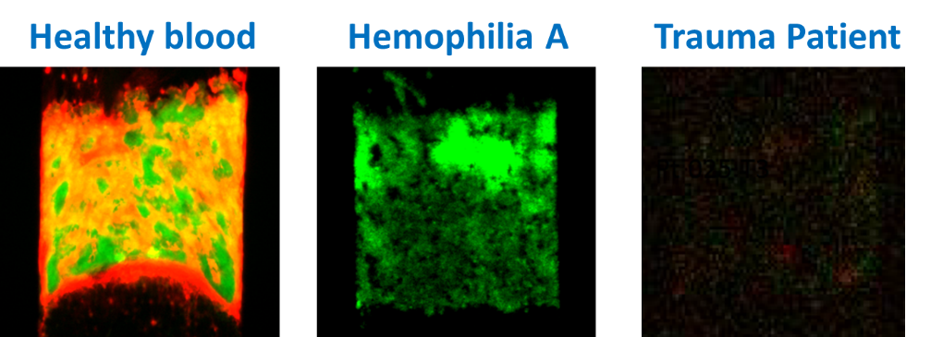
Direct (Specific) Detection with microfluidics hemodynamic

Example of Microfluidic Chip from internet
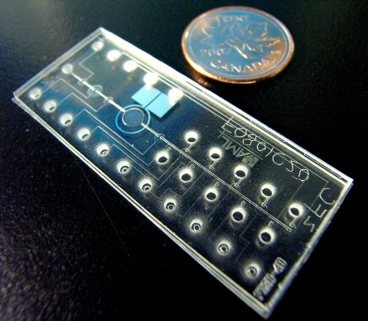
Do you have any specific imagery in mind for your logo?
The company is focused on advancing a microfluidic technology platform into the point of care (medical) arena. We are starting in blood, but other fluids (i.e. saliva, urine could also be a future development opportunity). Given the unique approach of the technology -- replicating the biology / hemodynamic flow conditions of the vasculature it would be interesting to explore imagery that communicates, flow, movement, small amounts of fluid emerging into robust output / signaling. We are open to exploring other areas that the team uncovers.
Do you have any preferences of what colors to use or not to use?
Do you use a color image scale like the kobiashi color scale? I have included an example I found on-line. Would be great to align on colors based on the imagery, personality we are trying to reflect.
Note: I have also incorporated a few POC competitor company / product logos for reference. We obviously want to stand out in the market
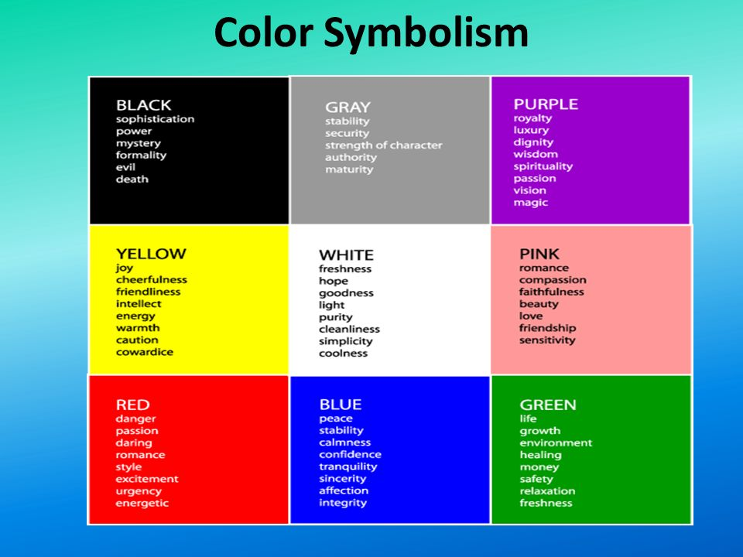
Words that pop out to me:
Sophistication, Stability, Strength, Simplicity, Urgency, Confidence, Integrity, Life, healing, Safety
What adjectives would best describe your logo?
Dynamic Fluid Complete Additive (more info)
Relevant Reliable making the complex simple Rapid
Flexible (platform) Peace of Mind Precise

Who is your target audience?
Main call point is anticipated to be in hospital institutions, calling on clinicians in critical care settings such as the Emergency Department, Operating Suite, Intensive Care Unit, etc.
Potential clinicians might include Hematologists, Surgeons, Trauma Specialists, Anesthesiologists, Neonatologists,
What kind of personality should your company project?
Precise (Results), Reliable (technology), Sophistication (simulating biology/flow), Systematic (range of parallel processes), Dynamic, Action Oriented, timely (information), Decisive (Valuable insight for Decision Making), Friendly (Easy to Use), Adaptable / Expansive (platform), Innovative, collaborative / cooperative (FloBio is part of the team’s decision making)
What is it you want to express with your logo?
Power / reliability of the technology platform that supports clinician’s real time information needs to make the best decisions for their patients.

What is the origin of the company’s name?
- FLO - Microfluidic technology conducts multiple processes under flow conditions
- BIO – Biology of the blood, the MF platform is designed in a way that creates a biologically relevant environment on the microfluidic chip that simulates what happens in-vivo.

Back Up Information

Hemostasis
Example of Hemostasis Cascade. FloBio has the ability to measure all of the components / stages on its microfluidic chip.
The point of care technologies focus on blood clot formation and fibrinolysis / degradation
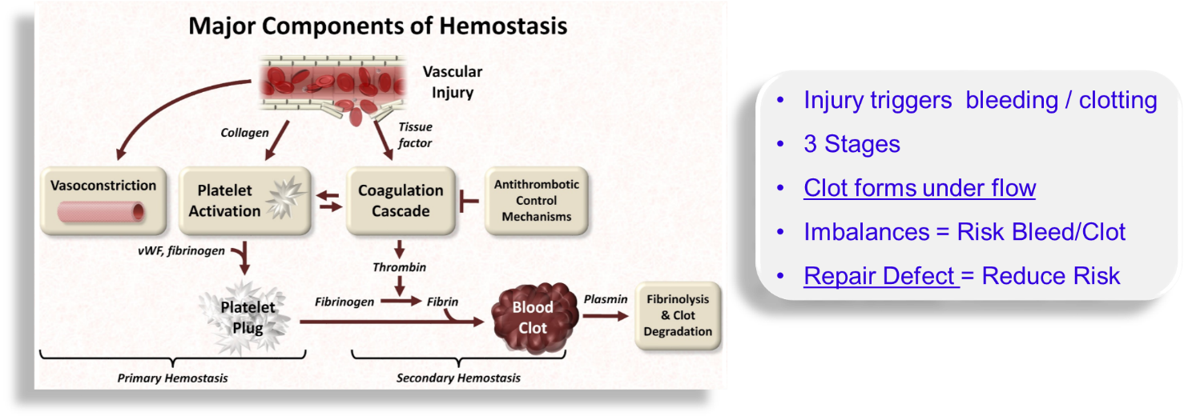

Competitive Company / Product Logos

- Instrument Laboratories




- Stago has acquired Hemosonics (developing a new POC Technology – Quantra)


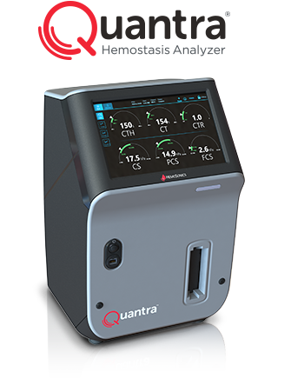


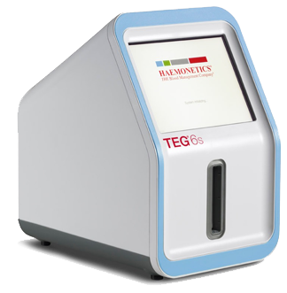
- Haemonetics has a product called TEG as well as a Plasma Blood Unit

