Company Name: RightAir, LLC
Short Description: Two million Americans have such severe COPD (a.k.a., emphysema) that they cannot walk up a single flight of stairs without the feeling of suffocation making them stop. The standard of COPD care is grossly inadequate and is composed of two main therapies. First are inhalers (bronchodilators and corticosteroids), which only marginally improve shortness of breath. Second is supplemental oxygen, which increases lifespan but surprisingly does very little for shortness of breath. Importantly, our patient population is defined as the 2 million COPD patients who are on maximal medical therapy (inhalers + oxygen) but still cannot climb a single flight of stairs due to terrible shortness of breath.
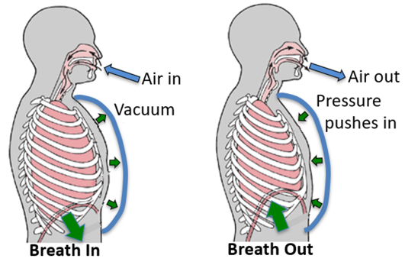
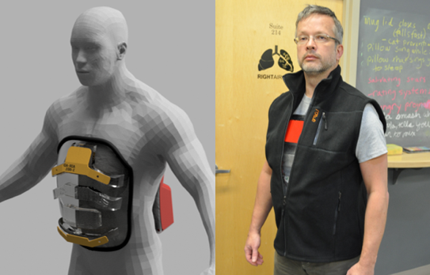
To resolve this feeling of suffocation, RightAir developed the AIR-AD vest (Fig 1, right panel). While the AIR-AD looks like a regular clothing vest, underneath it hides a light-weight, non-invasive ventilation device: a semi-rigid shell that fits over the anterior chest and abdomen (Fig 1, left panel). With each inspiration, the AIR-AD creates a negative pressure in the shell chamber that lifts the chest and abdomen, helping the patient inspire (Fig 1, left panel). With each expiration, the AIR-AD increases pressure in the chamber, helping patients to exhale (Fig 1, right panel). Thus, AIR-AD offloads the work of breathing, which numerous prior studies have shown will relieve the feeling of suffocation, thus allowing these patients to re-engage in the activities of life. Further, numerous studies have shown that increasing physical activity in these patients, as the AIR-AD vest will do, decreases their rate of costly hospitalizations.
Fig 2: AIR-AD during inhale (L) & exhale (R)
Fig 1: AIR-AD shell (left); vest covering (right)

What is the problem that your company addresses and how does your product solve this problem?
See above
Who are your competitors? How are you different?
See above
Do you have any specific imagery in mind for your logo?
Below is one we came up with, but we are open to others.
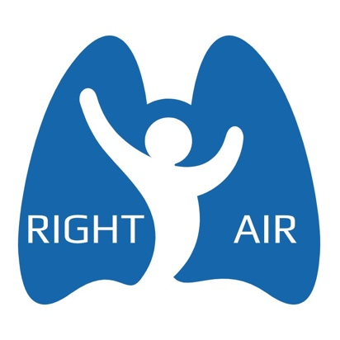
Do you have any preferences of what colors to use or not to use?
Colors that suggest air and breathing would be nice
What adjectives would best describe your logo?
Empowering, enabling, breathing, breath of fresh air
Who is your target audience?
COPD patients, mean age 65
What kind of personality should your company project?
Fighting for COPD patients
What is it you want to express with your logo?
We are going to end suffering for COPD patients and give them back their lives
What is the origin of the company’s name?
RightAir is kind of saying, “you have a right to air (breathe better)”, and we are going to “provide you with the right kind of breathing support”

